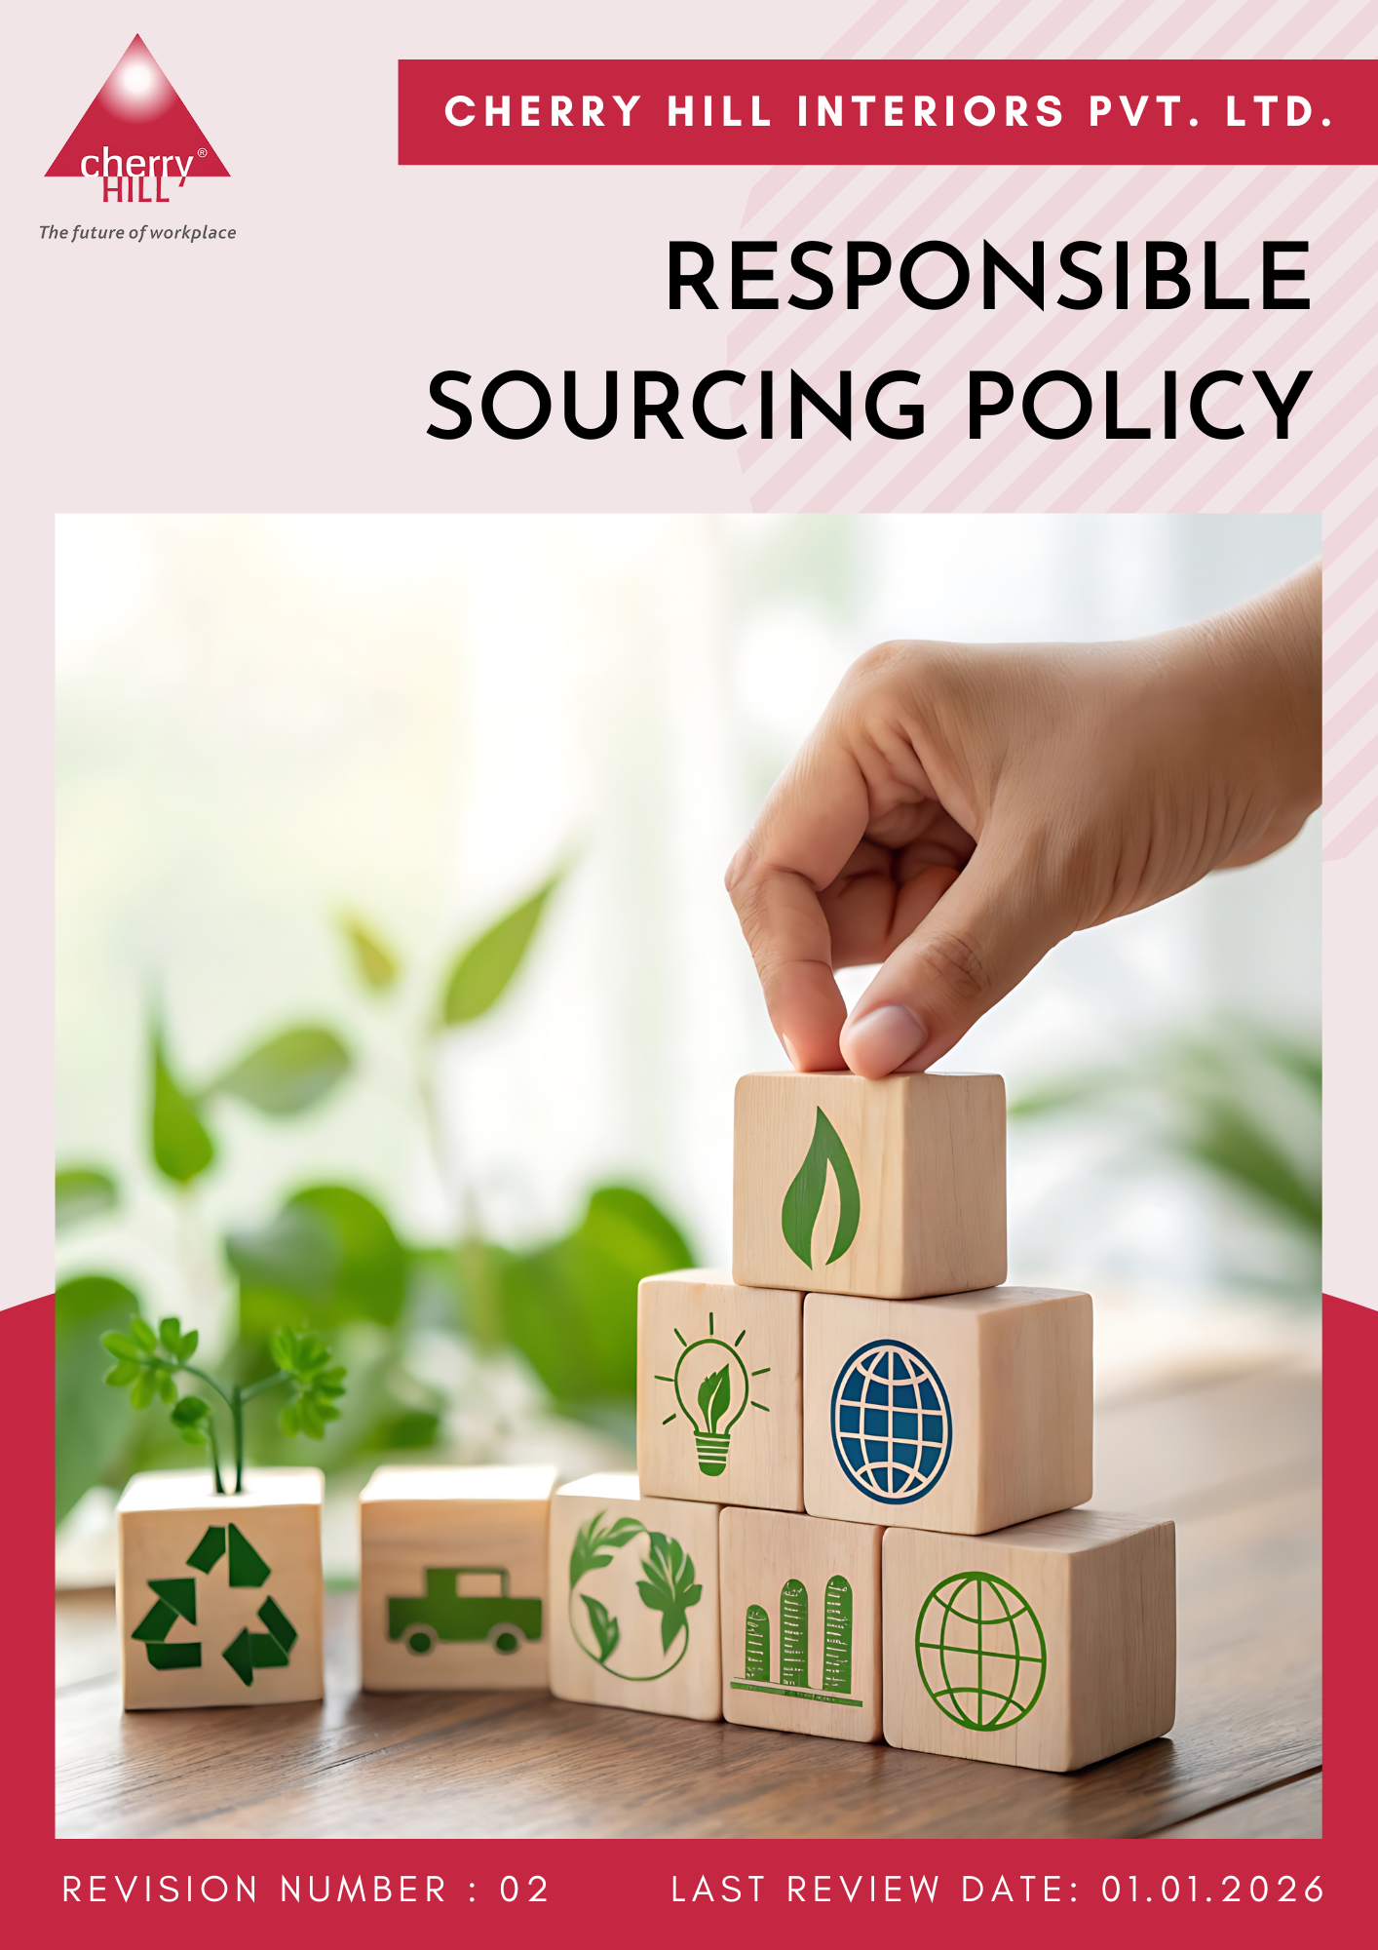
Contents
Preface 3
Scope 3
Policy Declaration 4
Key Action Areas 4
Qualitative Objectives 5
Targets based on our action areas 6
Responsibilities 7
Monitoring, Reporting and Transparency 7
Alignment with SDGs 8
Review Mechanism 9
Employee Acknowledgement Form 10

Preface
We at Cherry Hill Interiors Pvt. Ltd. integrate responsible sourcing into procurement decisions by prioritizing sustainability, ethical business practices, and social responsibility. Suppliers are expected to uphold environmental stewardship, fair labor practices, and regulatory compliance while minimizing environmental impact and promoting sustainable materials.
This policy ensures transparency, integrity, and accountability across the supply chain. By embedding responsible sourcing into operations, the goal is to drive positive change, support ethical business conduct, and contribute to a more sustainable future.
Scope
This policy covers all sourcing activities across office operations, project sites, and supply chains, ensuring ethical and sustainable procurement practices. It applies to employees, contractors, suppliers, and business partners involved in sourcing and procurement processes.
Sr. No. |  | Locations | Address
1. | Cherry Hill Interiors Pvt. Ltd. (CHIPL) | Delhi (Head Quarter) | Y-33, Okhla Industrial Area, phase-II, New Delhi, India - 110020.
2. |  | Bengaluru (Branch Office) | First floor, no 1, 14th a Main, Hall 2nd Stage, Bangalore, Karnataka, India - 560008
3. |  | Chennai (Branch Office) | GN Chetty Road, Anmol Palani, 88, T Nagar, Chennai, Tamil Nadu, India - 600017
4. |  | Pune  (Branch Office) | Liberty phase-2, Plot no. 323, Flat no.1, North Main Road, Koregaon Park, Pune, Maharashtra, India - 411001
5. |  | Hyderabad (Branch Office) | Third floor, Sreshta Marvel, Sy no 136, Gachibowli Konadpur Main Road, Gachibowli, Hyderabad, Telangana, India - 500032
6. |  | Factory | Plot no. 81-a, sector-5, IMT Manesar, Gurugram, Haryana, India - 122050
NOTE: The Ahmedabad, Kolkata, and Sri Lanka sites are not operational, and less than 1% of employees are from this location out of the total.
Policy Declaration
Cherry Hill Interiors Pvt. Ltd. ensures responsible sourcing by prioritizing ethical procurement, supplier accountability, and sustainable material selection. With Year 2022 as the baseline year, sourcing decisions are guided by transparency, fair labor practices, and environmental sustainability. Continuous improvements are made through supplier engagement, risk assessments, and collaboration with industry partners to uphold high standards across the supply chain.
Key Action Areas
- Environmentally Responsible Sourcing: Procurement of environmentally sustainable products and services.
- Supplier Social Responsibility: Promotion of fair labor and human rights practices within supply chain.
- Ethical Supplier Practices: Compliance with ethical standards and responsible business conduct.
- Local & Inclusive Sourcing: Engagement with local and diverse suppliers.
- Capacity Building & Training: Supplier development through training and awareness initiatives.
- Sustainable Wood Sourcing: Procurement of wood and wood-based materials from responsible and sustainable sources.

Qualitative Objectives
- Environmentally Responsible Sourcing
- Focus on engagement with the suppliers that comply with environmental certifications such as FSC, PEFC, and ISO 14001.
- Encourage suppliers to adopt sustainable production practices and comply with environmental regulations.
- Prioritize sourcing materials with low carbon footprints, high recycled content, or certified sustainability credentials.

- Supplier Social Responsibility
- Collaborate with suppliers who uphold labor rights, fair working conditions, and human rights.
- Conduct supplier self-assessments, audits, and remediation programs to monitor social responsibility performance and drive continuous improvement.

- Ethical Supplier Practice
- Ensure suppliers comply with all applicable laws, regulations, and anti-bribery and anti-corruption standards.
- Promote transparency, accountability, and integrity in supplier business operations.
- Foster a culture of ethical behavior and responsible decision-making throughout the supply chain.

- Local & Inclusive Sourcing
- Support local suppliers and communities, promoting regional economic development.
- Promote diverse supplier participation through inclusive procurement practices that consider cost, quality, and social impact.

- Capacity Building & Training
- Strengthen ESG knowledge and skills among suppliers and procurement teams through structured training programs.
- Support continuous improvement in supplier ESG performance through guidance, collaboration, and follow-up.

- Sustainable Wood Sourcing
- To promote responsible forest management through the procurement of sustainably sourced wood and wood-based materials.
- To strengthen supply chain sustainability by integrating environmental and legal sourcing considerations into wood procurement decisions.

Targets based on our action areas
- Environmentally Responsible sourcing
- Reduce procurement-related carbon emissions by 15% till year 2028 by prioritizing local suppliers and low-emission materials.
- Reduce overall procurement costs by 5% through sustainable and resource-efficient sourcing strategies by year 2028.
- Increase sourcing from suppliers holding recognized ISO certifications, public ESG disclosures, or validated sustainability commitments by 20% by year 2028.

- Supplier Social Responsibility
- Ensure 50% suppliers have implemented grievance mechanisms accessible to their workers and relevant stakeholders by year 2028.
- Ensure that 50% of active suppliers are assessed against social responsibility criteria, including labor practices, human rights, and workplace health and safety requirements, by 2028.

- Ethical Supplier Practices
- Train 100% procurement staff and key suppliers on ethical sourcing, labor rights, and responsible supply chain management by year 2028.
- Implement a supplier whistleblower mechanism with 80% of suppliers informed of the process by year 2028.

- Local & Inclusive Sourcing
- Increase procurement spend with local and diverse suppliers to 20% of total procurement spend by year 2028
- Achieve a 5% increase in engagement with women-owned suppliers by year 2028.

- Capacity Building & Training
- Provide ESG capacity-building training to 65% of suppliers by year 2028.
- Conduct two supplier capacity-building or collaboration initiatives per year focused on ESG improvement areas.

- Sustainable Wood Sourcing
- Procure 100% of wood and wood-based products from FSC, PEFC, or equivalent certified sustainable sources by year 2028.
- Reduce the use of virgin wood by ensuring 30% of wood-based materials in Cherry Hill Interiors’ projects are reclaimed or recycled by year 2028.
- Ensure 50% of sourced materials for interior projects, including wood, fabrics, and finishes, are recycled, renewable, or eco-certified by year 2028.
Responsibilities
- The Procurement Head ensures responsible sourcing practices and supplier compliance.
- The Compliance Officer monitors adherence and conducts regular audits.
- Project Managers and Designers integrate sustainability and ethical sourcing into all projects.
- Employees and Contractors follow responsible procurement guidelines and report violations.
- Suppliers and Business Partners maintain transparency and align with sourcing standards.
Monitoring, Reporting and Transparency
Cherry Hill monitors its sustainable procurement performance across all the above mentioned key focus areas. Defined Key Performance Indicators (KPIs) are tracked through procurement and supplier management processes to assess progress against established sustainability objectives and targets.
Performance is reviewed periodically and reported to management to support informed decision-making and continuous improvement. Regular assessments are conducted to identify achievements, gaps, and opportunities for enhancing supply chain sustainability performance. Relevant information and progress updates are communicated to internal and external stakeholders, as appropriate, to promote transparency and accountability.
All monitoring, reporting, and disclosure activities are undertaken in alignment with applicable legal requirements, industry best practices, and recognized sustainability standards.
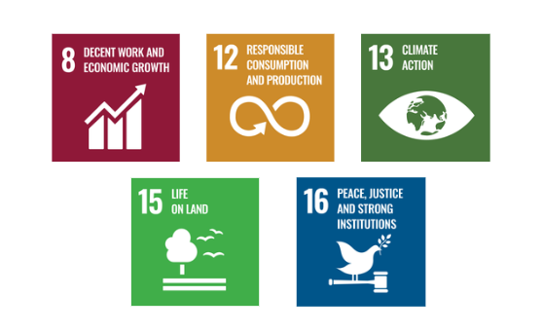
Alignment with SDGs

Review Mechanism
- The Procurement Head reviews this policy once after every two years or as required to ensure its relevance and effectiveness.
- Periodic internal audits and supplier assessments identify gaps and improvement areas.
- Feedback from employees, suppliers, and stakeholders is gathered to refine sourcing practices.
- Necessary revisions are made to align with evolving regulations, industry standards, and business needs.
- Senior Management evaluates findings and approves policy updates for continuous improvement.

Last Review Date | : 01.01.2026
Next Review Date | : 01.01.2028
Approved By | :

Employee Acknowledgement Form
I acknowledge that I have received, read, and understood the Responsible Sourcing Policy of Cherry Hill Interiors Pvt. Ltd. I agree to comply with the principles and guidelines set forth in this policy, including ethical procurement, sustainable material sourcing, supplier compliance, and responsible business practices.
I understand that it is my responsibility to uphold this policy in my daily work and report any concerns or violations through the appropriate channels. I acknowledge that failure to comply with this policy may result in disciplinary action in accordance with company regulations.
By signing this acknowledgment, I confirm my commitment to maintaining integrity, sustainability, and ethical sourcing practices in all procurement and supply chain activities.

Employee Name  Employee ID  Date  Signature | : _______________________________  : _______________________________ :________________________________  : _______________________________

